**Modifying the Regional SLR CGI Module to a Specific Coastal Location**

To modify the SLR module to a coastal town or city of the instructor’s choice, the only changes that need to be made in the Excel spreadsheet are to change the number of houses that will be impacted for each level of flooding and the associated probabilities of flooding at each water level for the four sea level rise scenarios (i.e. filling in the probabilities in Tables 2 and 3). The data comes from the Surging Seas Risk Finder website. The whole process takes approximated 10 to 15 minutes.

To do this follow the steps below:

1. Go to Surging Seas Risk Finder [website](https://riskfinder.climatecentral.org/) and type in the location you want your class focus on.

2. Scroll down to the “What Is at Risk?” Section and selection the “Buildings” tab.



3. Click the XLS icon next to “Total buildings” and a window will pop up.

4. Select All available categories then hit “Download”. Note: it will ask you to fill in your information, but you can skip this and go straight to Download.

5. Open up the Excel spreadsheet you just downloaded and find the row for “Homes” which shows the number of homes what will be impacted at each water level in your location.

6. Use these numbers to fill in Table 1in the CGI Module Excel spreadsheet in column B, “Total Homes”.



7. Next you need to fill in the missing probabilities for flooding at each water level for each sea level rise scenario in Tables 2 and 3. The probability data comes from the Risk Finder website. Go to the bar graph under the “When Are the Risks?” section and select the “Slow rise” scenario. Note: Make sure the graph is set to Multi-year risk of flooding (which is the default option).

8. If you hover over the bar for the year 2050, the percentage likelihood of flooding pops up. Use these percentages to fill in the “Probability” column in Table 2 in the CGI Excel spreadsheet for the “Slow” scenario for each water level by clicking on the different water levels on the gauge on the right side of the webpage. (Note: be sure to enter the percentage as a probability, i.e. type in 0.45 instead of 45%.)

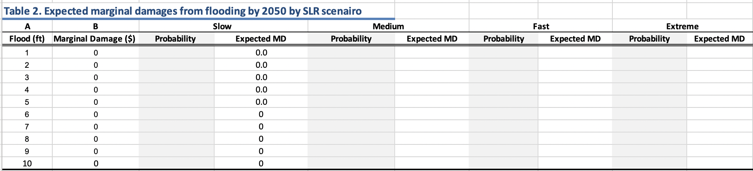

9. Repeat this process by filling in the probabilities for the Medium, Fast, and Extreme sea level rise scenarios in Table 2 (columns highlighted in grey).

10. Repeat the process again for Table 3, except now you will refer to the bar for the year 2100. Note you **do not** need to fill in the probabilities for the Medium scenario because your students will do this as part of the module. This part goes quickly since a lot of the probabilities are 1.0.

**Instructor Notes:**

* Be sure to specify the location (i.e. coastal city) you want to focus the module on at the beginning before the students complete the introduction section.
* The last part of the module has students estimate the distance of the sea wall to be built that will protect the most vulnerable part of the coast line. You can let the students decide where to build the sea wall and how long on their own or in small groups, or you can specify the place and length so students have the same marginal cost estimates for building the sea wall.